Development Documentation
Development Diary
Day 1 – Version 1.0
- Opened Visual Studio 2022 using ASP.NET Model View Controller, selecting .NET 9.0 and individual accounts for authentication type
- Installed 3 packages:
  - Microsoft.VisualStudio.Web.CodeGeneration.Design -Version 9.0.12
  - Microsoft.EntityFrameworkCore.Design -Version 9.0.12
  - Microsoft.EntityFrameworkCore.SqlServer
- 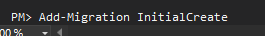
- I added migration and updated the database to create the SQL database for the individual accounts authentication type
- I ran the application with HTTP and tested logging in and registering
- 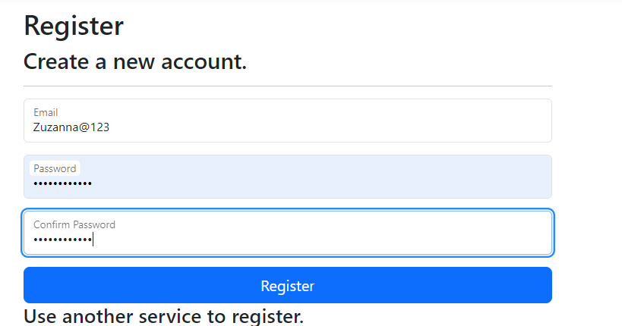
- 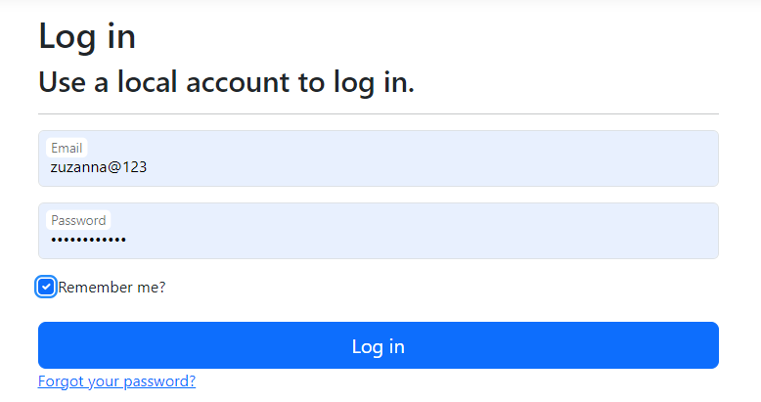
- No errors occurred
Models
- 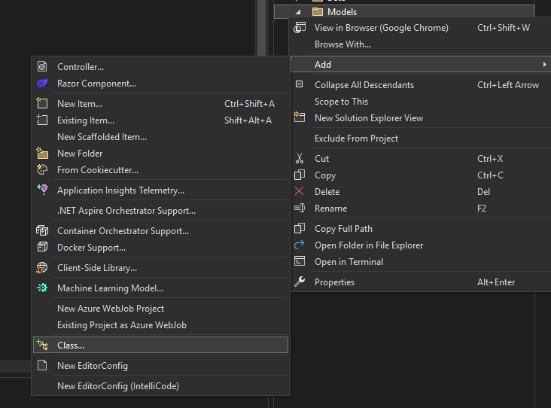
- To create a model, I right clicked on the “Models” folder, then went to add + class. I made a total of __ models:
  - Basket
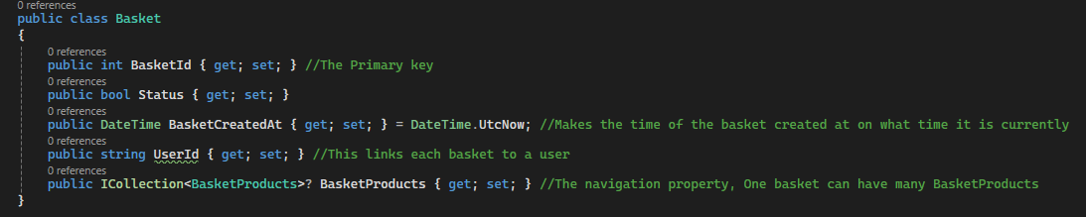
  - BasketProducts
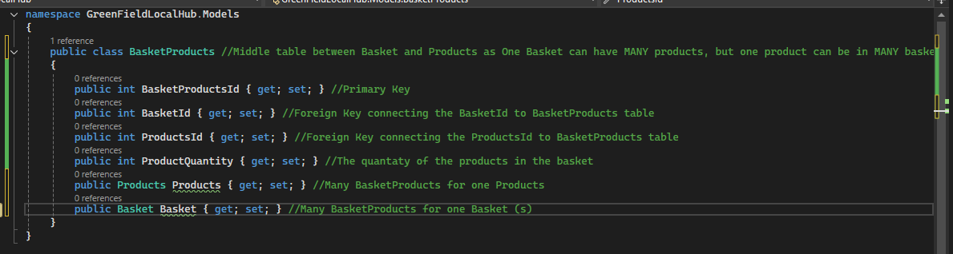
  - OrderProducts
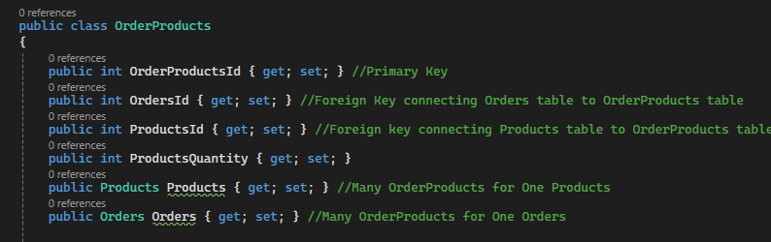

  - Orders
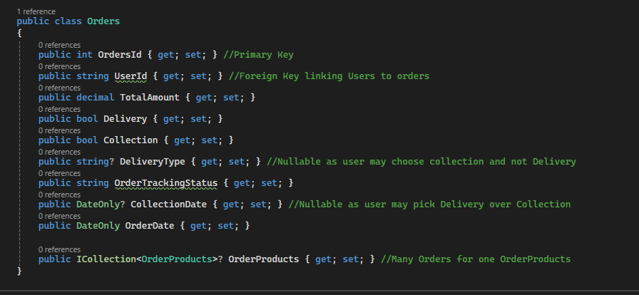
  - Products
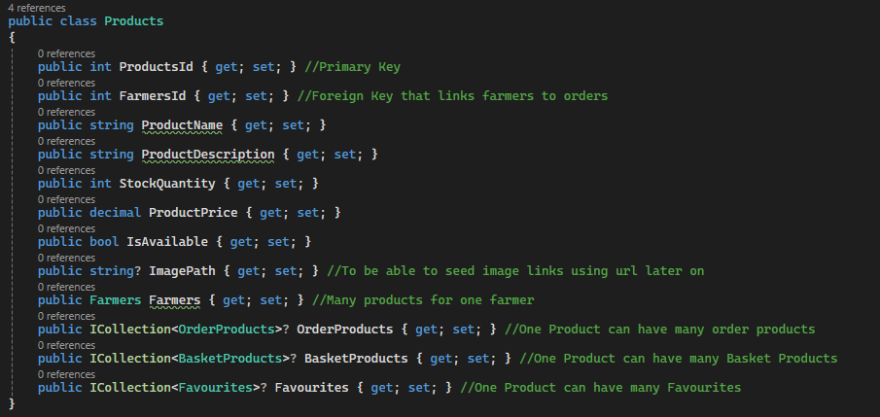

  - Farmers
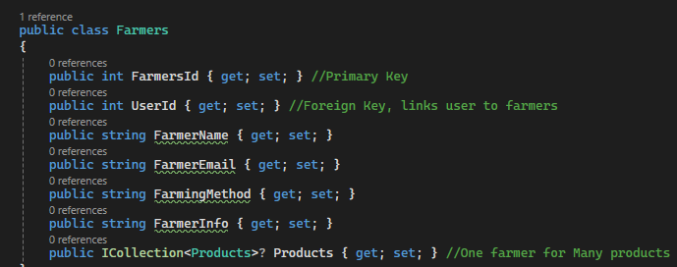
  - Favourites
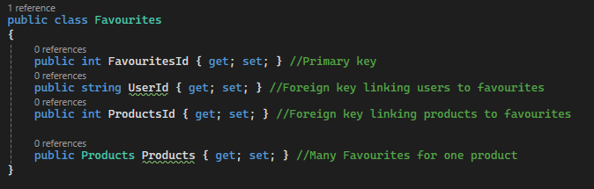
  - Loyalty Account
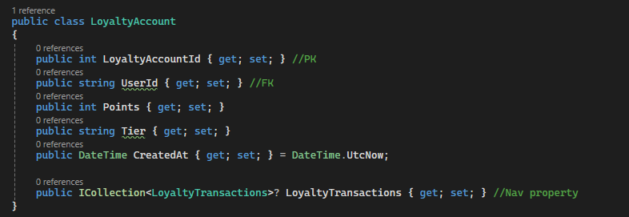

  - Loyalty Transactions
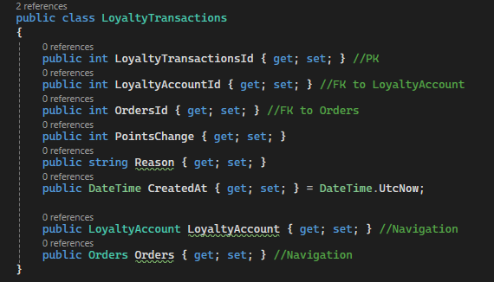
Controllers
- I am going to automatically scaffold each model for a controller, as each model needs one controller.
- 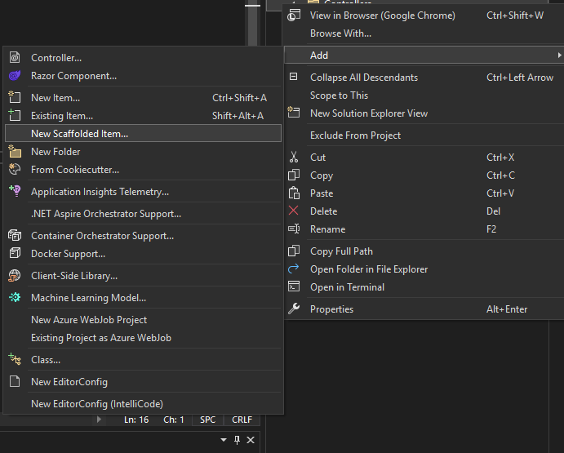
- I right click on Controllers folder, then do add + scaffolded item
- I use MVC controller with views, using Entity Framework as it will automatically create me controllers and views for each model
- 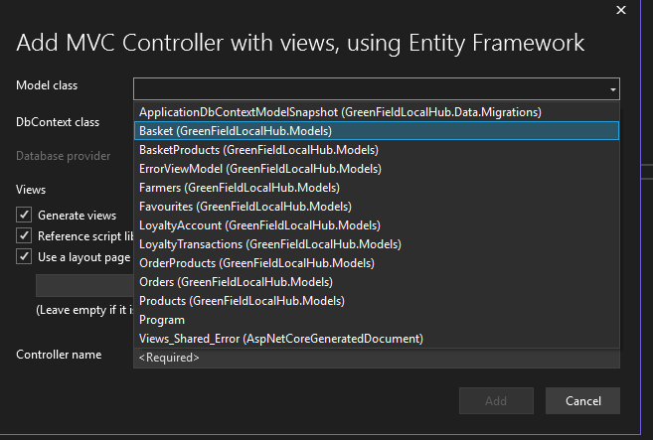
- I select each model I made and press add with DbContext class being applicationdbcontext
- Now I add migration and update database again
- I used HHTP to run the application to test the endpoints
- 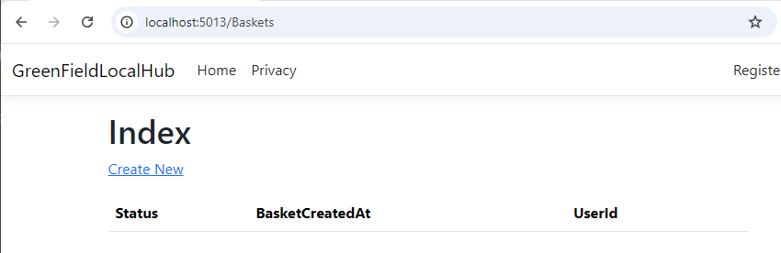
- This shows the Baskets endpoint works and has been created, it looks like that for each endpoint
Seeding Data
- Right clicked the Data folder and pressed add class, naming it “Seed Data”
- 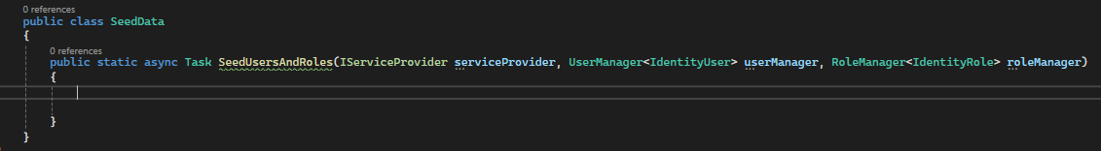
- Inside I wrote this line of code, which will allow me to pre-fill my database with default users and roles
- Added Admin, farmer, standard, loyalty, and developer roles
- X3 farmer roles
- Then in program.cs I added: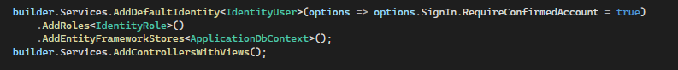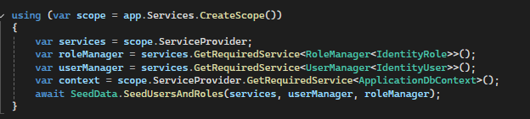
- Add migration and update database
- I run the application and test out the seeded roles
- 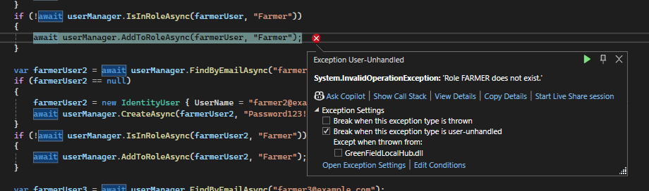
- Encountered an Error
- Take the seeded roles out of the foreach loop
- Test code again
- 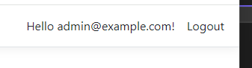
- Able to log in with seeded user roles
- Seed info in farmers table
- 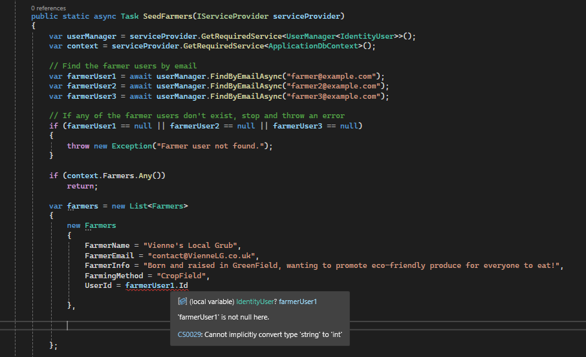
- When seeding farmer info, an error occurred saying “farmerUser1 is not null here”

- 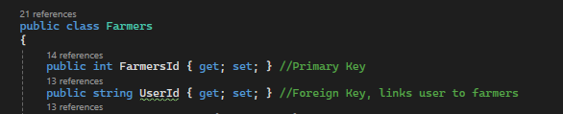
- Error was that in model, UserId was int instead of string, so I changed it to string
- Add-migration and Update-database
- 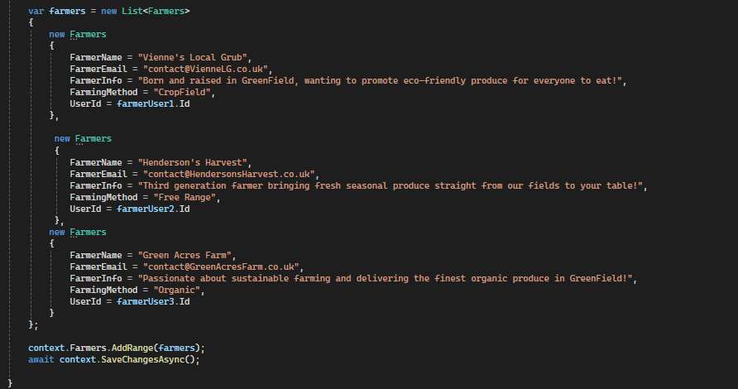
- Seed 3 farmers total
- In program.cs I added
- Run the code to see if the data has seeded
- 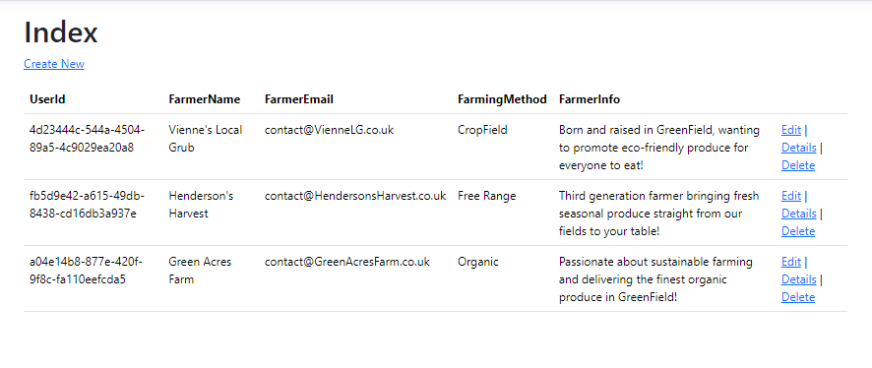

Versions of the Program – You can Title each entry from today, Version 1.1, 1.2, 1.3 and so on
- Treat this like a Diary with each session being a different version.
- Walk me through how you built the software justifying decisions you made along the way
- Talk about errors that you encountered and issues that you had and how you solved these issues
- Use Screenshots
Overall Documentation of Code
What is included in the Prototype?
Models
- For each model- what is the model, why did you make it and how is it being used in the program.
- Explain and mention the language of the code
- Screenshot the code
Controllers
- For each controller – what is the controller, why did you make it and how is it being used in the program
- Explain and mention the logic of the code in key methods that are being used, what is that method doing, where is it redirecting it to
- If you have passed through a search string mention how it works
- Make sure to explain and reference specific lines of code, can annotate screenshots if you want
- Explain and mention the language of the code
- Screenshot the code
Views
- For each view- What is the view, why did you make that specific view and how is it linked with the controllers and models
- Explain the language being used and the content on the page
- Screenshot the Views, both code and output
Styling
- Screenshot you CSS and explain the styling options you put in place and why
- Mention that is CSS

